109 學年度 正義國中第23屆正義盃學科能力競賽英語科考試 編號：
注意：(1)選擇題：1~35 每題2分７０％; 36~45:每題3分３０％共100%
(2) 答案請寫在答案卷上; 測驗結束，題目卷及答案卷同時繳回。
(3) 請用黑色 或藍色 原子筆 作答。

I. Vocabulary: 1~35 每題2分
1. Because of the outbreak of COVID-19 (新冠病毒), people have to wear a mask all the time to ____
ourselves and others.
(A) punish (B) protect (C ) provide (D) promise
2 . The day after Wednesday is ___________.
(A) Thursday (B) Tuesday (C ) Saturday (D)Monday
3. David: “Do you know them?”
Tom: “Yeah. They often come around here to borrow ___________.”
(A)anything (B)something (C )nothing (D) everything
4. In ____ in the mountains, the tree leaves turn brown.
(A) summer (B) winter (C )spring (D) autumn
5. A ______ is a place where you can watch TV and chat with others.
(A) kitchen (B)bathroom (C )study (D) living room
6. My father is a _____, who sells fried chickens on the street. And I am proud of him.
(A)vendor (B) lawyer (C )engineer (D) firefighter
7. You should _____ making the same mistakes again and again.
(A) celebrate (B) practice (C )avoid (D) succeed
8. Look at the picture on the right. The bear is playing___________.
(A) soccer (B) baseball (C )basketball (D)badminton
9. Tina is my aunt, so I am her _______.
(A)cousin (B) brother (C )niece (D)uncle
10.Everyone loves to be Tom’s friend because Tom is very ________.
(A)lonely (B)hardly (C )friendly (D)happily
11. What is the boy playing, according to the picture?
(A) the drum (B)the guitar (C )the piano (D)the kite

II. Grammar:
12. A boy and a girl were sitting on a sofa; ____ boy was smiling but____girl was angry.
(A)the; the (B)the; a (C )a; a (D) a ; the
13. My father is reading a book, and the name of ____ is Snow White.
(A) this (B) that (C )which (D) it
14.Tom _____ a lot of time studying English, and it works.
(A) takes (B)spends (C )pays (D)costs
15. _______ a concert next week.
(A)There will have (B) It is (C )There was (D) There will be
16. These are Mary’s books, and those are _______.
(A) his’s (B)my (C ) ours (D)your
17. Tom:I don’t like the movie we saw last night. How about you?
David: Otherwise!
Question: Does David like the movie?
(A) He likes it. (B)He doesn’t like it. (C ) So so! (D) He has no feeling.
18. I hate exercise, but my father ____ me walk a dog every day.
(A) allows (B) makes (C )lets (D)helps
19. Go after what you want, ____ you may not believe that it is possible.
(A) though (B) as (C ) because (D)unless
20. Tom,___ nice to the poor.
(A) has (B)be (C )being (D)is
21. Every student _______to school every day.
(A) is going (B) went (C )go (D) goes

III. Cloze :
題組 1:
A man called Ali Baba lived in a town. He lived by cutting wood and took it upon his horses to the town to sell. One day, when he was in the forest, and he just cut enough tree branches to 22 his horses, he saw a lot of people coming near him. He watched it closely and found that they might be 23 . In order to save himself, he 24 to leave his horses. He climbed up a large tree, planted on a high rock, 25 branches were thick enough to hide him from being seen. These horsemen came to the foot of the rock on which the tree stood. Then, Ali Baba heard the leader of the horsemen say words, “Open, Sesame!” Then, a door opened in the rock. Ali Baba was shocked that a lot of gold was inside.
22.(A) feed (B)load (C )cover (D) frighten
23. (A) thieves (B)policemen (C )students (D)teachers
24. (A) made up his mind (B) came up with (C ) got on (D) ran out of
25. (A) that (B) which (C )whose (D) where

題組2:
Jason was sick because he ate too much 26 Saturday night. He had hamburgers, French fries, pizza and a lot of ice cream. He couldn’t sleep that night, 27 he went to the doctor with his mother the next day. The doctor said, “You are sick because you ate too much. 28 some medicine and stay away from fast food.” Jason followed the doctor’s advice. He had to 29 in bed all day. He learned a hard lesson.
26.(A) on (B) at (C ) during (D) in
27.(A) but (B) though (C ) so (D) for
28.(A)Taken (B)Take (C ) To take (D)Taking
29.(A) being (B) was (C ) is (D)be

題組3:
Candy and Wendy are close friends, and they are chatting.
Candy: You often drink coffee, don’t you? 30 do you drink it?
Wendy: Every day. I cannot live 31 coffee.
C: 32is a cup of coffee?
W: NT$40.
C: So you spend at least ten thousand dollars a year on coffee.
W: 33 .
C: Why do you need it so much?
W: Drinking coffee can 34 me to feel energetic all day long. How about you?
C: I don’t like any kinds of drinks, 35 I like water.
W: You are so smart. Water not only is healthy but also costs you less money.
30. (A)How often (B) How soon (C ) How much (D) How many
31. (A) with (B) for (C ) of (D) without
32. (A)How often (B) How soon (C ) How much (D) How many
33.(A) I have the lion’s share! (B) I beg your pardon!
(C )You can say that again! (D) None of your business!
34. (A)help (B)let (C )make (D)have
35. (A) so (B) but (C ) and (D) neither

IV. 總合題：36~45: 每題3分
36. Now, it is a quarter to eleven in the morning. Please draw the correct time in the clock.(圖1)

37.Dragons are seen in many stories. Chinese dragons are often pictured with a magic ball in their mouth, Please draw the place where the ball is put. (圖2)

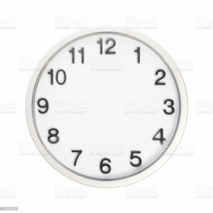
圖2
圖1
V. Reading comprehension:
Reading 1:
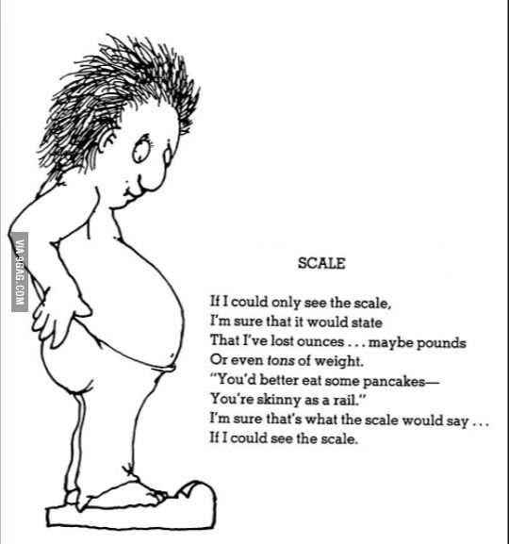
38. What happened to the man?
(A)He lost weight and he could eat some snacks.
(B)He actually lost a lot weight and became so thin.
(C )He wishes that the scale showed him the correct fact.
(D)He cannot see the scale because he gains lots of weight.

Reading 2:
Sally, John, Peter and Lisa are junior high school students. Sally goes to school by bus. John lives near the school. He walks to school every day. He is never late for school. Peter always gets up late and goes to school late, too. His homeroom teacher is mad at his being late for school. Lisa goes to school and gets back home by MRT. Sometimes, she meets her math teacher on the MRT. He is fun and Lisa likes him very much.
39.Who goes to school on foot?
(A)Sally (B) John (C) Peter (D) Lisa
40.Who will make the homeroom teacher unhappy?
(A)Sally (B) John (C) Peter (D) Lisa
41.Who is him?
(A)Sally’s math teacher (B) John’s math teacher (C) Peter’s math teacher (D) Lisa’s math teacher

Reading 3:
Everyone grumbled.
The sky was gray.
We had nothing to do and nothing to say,
We were near the end of the day.
And then, there appeared to be nothing beyond.
Then, Daddy fell into the pond.

And everyone’s face grew bright.
And Timothy danced for full delight.
“Give me the camera, quick, oh quick!
He’s getting out of the water!” Click!

Then the garden man hit his knee, bowed,
And laughing, shaking silently!
We did nothing,
When
Daddy fell into the pond! (Rewrite from a poem by Alfred Noyes’s When Daddy fell into the Pond.)
42. Timothy felt __________when daddy fell into the pond?
(A)sad (B)surprised (C )happy (D)excited
43. For kids, it was a ___________ day.
(A) busy (B) boring (C) tiring (D)exciting
44. What time was it when father fell into the pond?
(A)6:30 am (B)12 at noon (C )2:30 pm (D)5:30 pm
45. What can we know from the poem?
(A) The family is a happy and pleasant family.
(B)The father is not so popular in the family.
(C )The stranger is so friendly to help the man.
(D)Kids love their father so much.

