111年第24屆正義盃學科能力競賽 雙語閱讀素養試題(英語文閱讀)
I、辨識句意 (共8分，每題2分) (說明：選出與題目意思相符合的圖片。)
- The little boy is putting his tongue out.

(A) (B) (C)
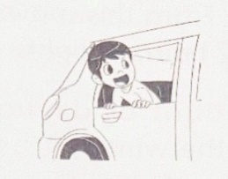 | 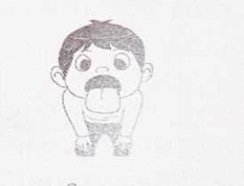 | 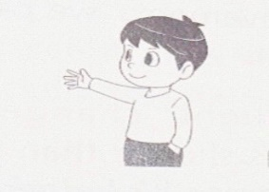
- Judy felt dizzy after the ride.

(A) (B) (C)
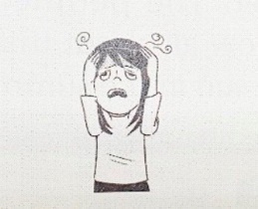 | 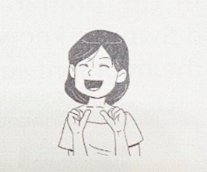 | 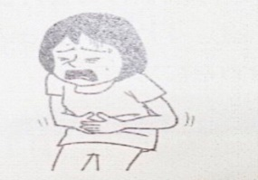
- The two students are cleaning the blackboard.

(A) (B) (C)
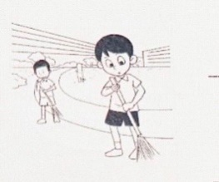 | 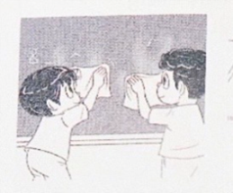 | 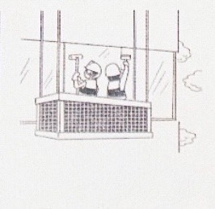
- Jeff and Nick are on the tennis court.

(A) (B) (C)
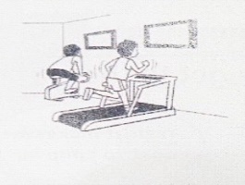 | 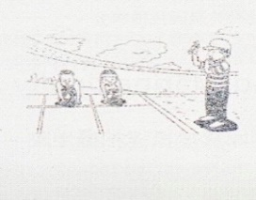 | 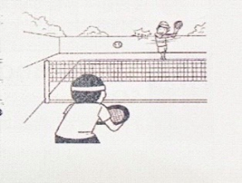
II、看圖回答問題(共4分，每題2分)
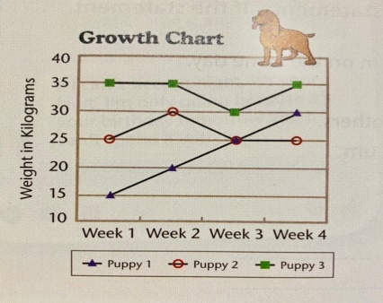  (Picture 1) | 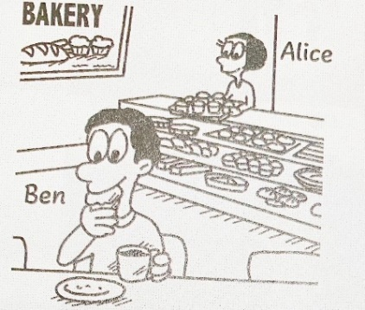  (Picture 2)

- According to Picture 1, when were two of the puppies the same weight? ※ weight 體重

(A) In the fourth week (B) In the third week (C) in the second week (D) In the first week

- According to Picture 2. Who is Alice?

(A) She is an English teacher. (B) She is the owner of a candy shop.
(C) She is a waitress at a steak house. (D) She is a clerk at a shop with baked goods.
III、克漏字選擇(共16分，每題2分)
Question 37~40
Jimmy is in the waiting room at his doctor’s office. When his doctor is ready to see him, he goes in and has a seat. The doctor asks him what’s wrong, so he tells her that he thinks he 37. a cold. He has a headache, bad cough, and stuffy nose. Jimmy tells the doctor that he didn’t 38 after he got home from school last Friday. His throat was sore, and it 39 to swallow. Jimmy’s doctor thinks he has the flu because he also has a fever. 40. A shot will take care of his health problems.
※ ready 準備好 ; headache 頭痛 ; stuffy 塞住的 ; sore throat 喉嚨痛 ; swallow 吞嚥 ; shot打針

37. (A) gets (B) having (C) caught (D) catching
38. (A) wait (B) feel well (C) think (D) know
39. (A) heard (B) got (C) needed (D) hurt
40. (A) She tells him it can’t be cured. (B) She says he needs surgery.
(C) She tells him not to worry. (D) She has no idea what to do about it.

Question 41~44
In the West, Christmas is a big holiday. It is celebrated 41. December 25 each year. People give gifts to their friends and family members. They also 42. Christmas trees to make them look beautiful. 43. , they see warm fires, white snow, and cold winters in their minds. However, in some countries, like Australia, South Africa, and New Zealand, it is not cold or snowy at Christmas. For them, the seasons are 44. because they are in the south half of the Earth. So, they experience Christmas in summer.
※celebrate 慶祝 ; Australia 澳洲; experience 體驗

41. (A) for (B) in (C) on (D) at
42. (A) decorate (B) grow (C) move (D) cut
43. (A) When people think of Christmas (B) Although people enjoy good food
(C) Before people start singing (D) Since people love gifts
44. (A) different (B) scary (C) human (D) loud
III、短文理解 (共8分， 每題2分)
45. What kind of pet does Alex have?
Alex is talking about his pet Lidia with his friend Jack. Lidia’s food is in the tank here. You’ll need to give her one mouse on Tuesday and another on Friday. She doesn’t bite, but she’ll circle her whole body and tail around things. Also, it’s time for her to lose her skin. So, she will do that this week.
※ bite 咬 ; circle 圈 ; around 繞著
(A) A cat (B) A snake (C) A tiger (D) A penguin
46. In the picture, where can we find gills?
Sleep is important to not only animals but also fish. Fish don’t sleep like us because they live in water. They breathe by closing and opening their mouths to push water over their gills. When fish sleep, they keep swimming and moving with their fins. If they stop, they can’t move water over their gills and can’t breathe.
※breathe 呼吸 ; fin 鰭
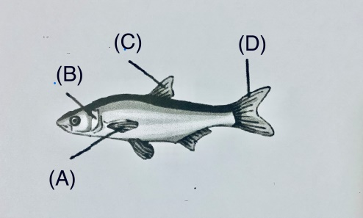
47. Which number is NOT used?
It’s fun to play with numbers. Your brother has three fish bowls. There are two fish in each one fish bowl. How many fish does your bother have? Your mother gives you three dollars in Week 1, six dollars in Week 2, and twelve dollars in Week 3. She keeps giving you money this way. In Week 5, how many dollars does yours mother give you? In Week 6, how many dollars does your mother give you? I hope you have all the right numbers.
Question 47:
(A) 6 (B) 48 (C) 17 (D) 96
48. How did Anne feel about her first dinner party?
Anne went to her first dinner party last night and had a great time. There were many interesting people there. They talked about all kinds of things, and everyone listened to each other. She never experienced that before. In her mind, dinner parties were boring, but she was wrong.
※interesting 有趣的 ; experience 體驗
- She felt boring all night. (B) She had fun there. (C) She was wrong to go there. (D) She felt unhappy.
IV、閱讀理解 (共14分， 每題2分)
Question 49~52
Alex quickly does his homework and leaves the house. “Don't forget to take your younger brother!” yells his mom behind him. “OK,” says Alex. He finds his little brother, Jeff. He is outside playing with a small caterpillar. “Come on, Jeff. Let's go. Do you want to use the roller-skates or the bicycle?”“I want to use the bicycle,” says Jeff. Alex roller-skates down the street and Jeff rides his brother's bicycle. The bicycle is a little too big for Jeff. He has to stand up to ride it.
They first go to the store to check out the comic books. “Excuse me, sir. How much are the Spiderdog and Wondercat comic books?” asks Alex. The man replies, “They are five dollars together.” Eric gives the man five dollars, and he and Jeff quickly ride to their next location. This time it is a candy store.
“ Excuse me, sir. How many pieces of Yumyum gum do you have?” “Well, I have only 2 pieces left. You can buy them for four dollar,” says the man.
Finally, it is time to go home. They go home tired but happy. Jeff is chewing on a piece of Yumyum gum and Alex happily reads his new comic books.
※ caterpillar 毛毛蟲; check out 查閱 location 地點 gum口香糖 chew 嚼 it is time to …該是…的時候了

49. Alex goes to the store on _____.
(A) a skateboard (B) roller skates (C) a bicycle (D) foot
50. What kind of candy do the boys buy?
(A) chocolate (B) sweet candy (C) chewing gum (D) sour candy
51. How much is one piece of gum?
(A) nine dollars (B) two dollars (C) four dollars (D) five dollars
52. Where do the boys visit?
(a)1→2→3→4 (B) 3→4→1 (C) 1→2→3 (D) 2→3
- a park | - a bookstore | - a candy store | - a bakery
Question 53~55
Sherry’s Summer School Timetable
 | Mon. | Tue. | Wed. | Thu. | Fri.
09:00~10:30 | piano | swimming | painting | piano | swimming
10:30~12:00 | English | math | English | science | English
13:30~15:00 | soccer | games | skating | games | soccer
53. How many times does Sherry play soccer every week?
(A) Once (B) Twice (C) Three times (D) Four times
54. Which of the following is true?
(A) Sherry goes swimming three times a week. (B)Sherry plays the piano on Mondays and Thursdays.
(C) Sherry studies English only once a week. (D) Sherry plays games in the morning.
55. When does Sherry study art?
(A) On Monday afternoons. (B) On Friday mornings
(C) On Thursday afternoon. (D) On Wednesday mornings

